Input Management

This subsystem take inputs from the user and makes the other subsystems be aware of the process. With the help of Input Manager the program can perceive user's commends.

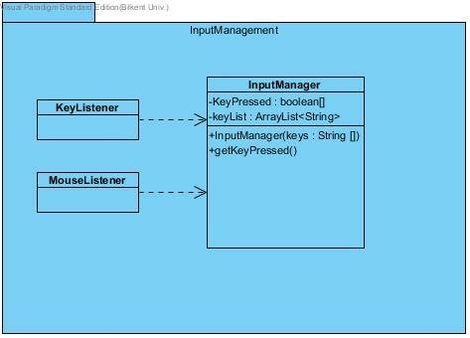

Input Manager

“InputManager” class is the listener class of the system. "KeyPressed" keep the information of the button whether pressed or not. "keyList" is array that keeps the list of the buttons. "getKeyPressed()" is called by "Game Manager" to check the pressed buttons.

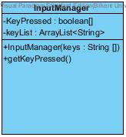

Collision Manager

"Collision Manager" has only relationship between "Game Manager". It take some data(GraphicGrid, Entity Grid) from there. "initializeCollision()" method is used by "Game Manager" to find out whether there is a collision or not.

